Geometry Quiz Parallelogram REVIEW 6.2-6.3 Name_____________________________________

1. Definition of a Parallelogram:

Properties:
Sides | Angles | Diagonals
2. | 3. | 5.
 | 4. | 6.

Fill in the blank with the correct word.
CHOICES
Congruent
Supplementary
Bisect

7. The opposite sides of a parallelogram are __________________.

8. The opposite angles of a parallelogram are _________________.

9. The consecutive angles of a parallelogram are _______________.
Study these properties!
There will be questions like this on the quiz!

10. The diagonals of a parallelogram ______________ each other.

Look at the markings on the picture to determine if the quadrilateral is a parallelogram, and if so, why.
Choices are:
Opposite sides are ≅. | Opposite sides are ||. | Opposite angles are ≅.
Consecutive angles are supplementary. | Diagonals bisect each other. | Not a parallelogram (None)

11. 12. 13. 14.

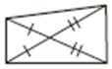
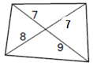
15. 16. 17. 18.

Find the measure of each angle or length of each segment.
19. RTVW is a PARALLELOGRAM  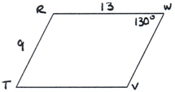  WV=_______ VT=________  m∠R=_______  m∠T=______  m∠V=______ | 20. MKGF is a PARALLELOGRAM  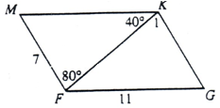  m∠1=_______ m∠KFG=______  m∠MFG=_____ m∠M=______  m∠G=______  MK=________ KG=___________ | 21. AESN is a PARALLELOGRAM  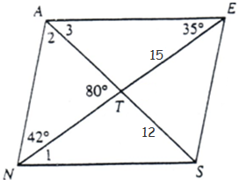  m∠1=______ m∠ANS=______  m∠NAE=____ m∠2=______  m∠3=_______ m∠ETS=______  AT = ______ AS=______  NT=______ NE =______

JKLM is a parallelogram. Find JK and KL. WXYZ is a parallelogram. Find the missing angle measures.

22. 23. 24. 25.

JK = _______ KL = ________ JK = _______ KL = ________ m∠X = ______ m∠W = ______ m∠Z = _____ m∠W = ______

m∠Y = _____ m∠Y = ____

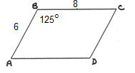
BCDE is a parallelogram. Find the segments.
26. 27. 28.

DF = _______ BD = ________ DF = _______ FB = ________ m∠C = _____ m∠D = ____

CD = ____ AD = _____

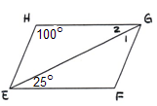
29. a. m∠F = _______
b. m∠FGH = _____
c. m∠2 = _______
d. m∠1 = _______

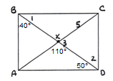
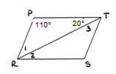
30. a. m∠S = ______ 31. a. m∠1 = ______
b. m∠PTS = ______ b. m∠2 = ______
c. m∠3 = ______ c. m∠3 = ______
d. m∠2 = ______ d. AX = _____ AC=_____

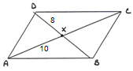
32. a. BX _______
b. BD_______
c. XC _______
d. AC _______

Use the properties of parallelograms to write and solve an algebraic equation for each picture.
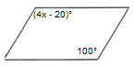
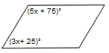
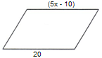
33. 34. 35.

Parallelogram Rule: Parallelogram Rule: Parallelogram Rule:

Relationship: Congruent or Supplementary Relationship: Congruent or Supplementary Relationship: Congruent or Supplementary

Equation: Equation: Equation:

x = _______ x = _______ x = _______

Use the properties of parallelograms to write and solve an algebraic equation for each picture. Find x and y.
36. 37.

Parallelogram Rule: Parallelogram Rule:

Relationship: Congruent or Supplementary Relationship: Congruent or Supplementary

Equation: Equation:

x = _______ y = _______ x = _______ y = _______
$$m = \frac{y_{2} − y_{1}}{x_{2} − x_{1}}$$

38. Find the slope of each segment to determine if the quadrilateral is a parallelogram.
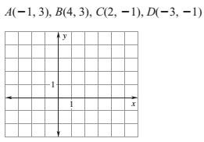
Slope of $\overline{\text{AB}}$ Slope of $\overline{\text{CD}}$

Slope of $\overline{\text{BC}}$ Slope of $\overline{\text{AD}}$

a. Which segments have the SAME SLOPE? ________&_______ and _______&_______
b. Lines that are PARALLEL have the same slope. So, which segments are parallel? _______&______ and _______&______
c. Why is Quadrilateral ABCD a parallelogram?

