Green Eggs and Ham: Second Grade Lesson

RHYME TIME - RHYMING LESSON PLAN

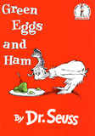
One of the most beloved books that has ever been penned by Dr. Seuss is Green Eggs and Ham. Published in 1960, it remains the fourth best-selling children's book of all time.
The story revolves around two characters: Sam-I-Am and the unhappy focus of Sam's attention, who is unnamed and rather cranky. What is it that Sam is trying to get the character to do? Why, try green eggs and ham, of course!
Like many mothers, frustrated with children's fondness for refusing new foods, Sam tries every way possible to get the attention of his victim...I mean, friend. He offers the delicacy on a train, with a goat, in a house, and many other variations of company and place. Each time the offer is made, it is grumpily turned down, and yet Sam does not give up.
There are only 50 words total in this story, and many are rhyming.
Lesson Warm-Up
Ask students what rhyming words are (words that have the same ending sounds). Tell students to touch their nose when they hear words that rhyme during a practice activity with the following words:

Words: (cat, hat) (mix, cap) (see, be) (do, at) (hip, dip) This is when the teachers assess students’ understanding of rhyming. Do they have it?

Introduction/Procedure
Do a read aloud with Green Eggs and Ham, a rhyming book, and all the students need to do is listen carefully and enjoy.
Tell the students that we will read the book once more. Remind students that this picture book has rhyming words in it. Students will be the “rhyme detectives” and must touch their noses when they hear two or more words that rhyme.

When students touch their noses, stop reading and ask students to identify the words that rhyme. Write each of these words on the board. (Optional – instead, write the words on index cards and place them in a pocket chart)

When you are finished reading the story, you will have plenty of rhyming words. Focus on the pairs of words that rhyme and review them with the class. Call on students to read the rhyming words. When all of the pairs have been read, go through all the words as a class, with everyone saying each word together.

Tell students that they will now have a chance to make and play their own rhyming game! Pass out the rhyme cards printable and ask students to cut out the cards if they’re not already cut out. Pass out baggies for students to store their cards in if necessary.

Ways to play the game:
• Students can play in pairs or independently, mixing up the cards and finding rhyming pairs.
• Students can play the game like Concentration, turning over and mixing up the cards.

Closure
Say one rhyming word and point to students in the class to tell you a word that rhymes with it.

Follow-Up Activity

Think of three pairs of words that rhyme -different ones from the ones we heard in the story, Green Eggs and Ham.
Write the three pairs of words on the lines
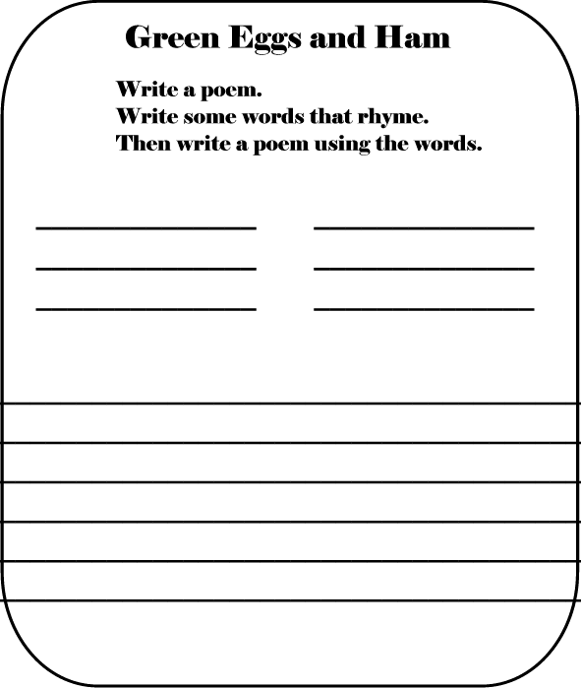
Begin with your first pair of words. Write a sentence that ends in each of the words. These are the first two verses of your poem. Do the same thing for the other two pairs of rhyming words. You’ve written a poem!
Green Eggs and Ham

