Name:

Geometry – Final Exam Review – Part 1

- GET ORGANIZED. Successful studying begins with being organized. Gather up all of your notes and review packets from this semester. Bring this packet with you to class every day.

- DO NOT FALL BEHIND. Do the problems that are assigned every night and come to class prepared to ask about the things you could not do.

- GET SERIOUS. The grade you earn on this exam is worth 20% of your semester grade.

- MAKE NOTES AS YOU WORK. As you do these problems, you will come across formulas, definitions, and examples that you will want to put on your notecard.

- START YOUR NOTECARD NOW: Your notecard must be in your own writing. You may put on it anything you think will help you on the exam. You may use the front and back. You will turn it in with your exam.

- There is nothing on the exam that is not reviewed. There is nothing on the exam that you have not studied this year. You will turn in your review packet after you take your test.

- This packet is worth a 1-weight quiz grade. This grade is based on:

- Completion. I will check each day to make sure that day’s work is done.
- Correctness. I will check random problems to make sure they are correct, or that you made corrections as needed. Make corrections in another color!
- Participation. I will keep track of people who work during class, ask questions, and answer questions. Everyone needs to participate in class discussions at least three times.

Date | Assignment | ☑
Friday, June 2 | Chapter 7
Monday, June 5 | Chapter 8
Tuesday, June 6 | Chapter 9
Wednesday, June 7 | Chapter 10
Thursday, June 8 | Chapter 11
Friday, June 9 | Make notecard

Geometry Final Exam Review – Ch. 7 Name:_________________________________
Hour: ____
Simplify the ratio.

1. 2. 18 ft: 9 ft 3. 4. 5.

Solve these proportions by cross-multiplying. Use the distributive property, if needed. Show your work!

6. $\frac{x}{5}=\frac{6}{4}$ 7. 8 : 3 = x : 6 8. $\frac{2}{9}=\frac{x+2}{8}$ 9. $\frac{x+4}{5}=\frac{3x−2}{\text{10}}$
Proportion:

Set up a proportion to solve the following problems.

10. If 25 Popsicles cost $20.00, then 11. Thomas finished 50 problems
how much will 42 Popsicles cost? in 20 minutes. At this rate, how many
problems can he do in 30 minutes?

Proportion: Proportion:

In #12-15 use the following situation to answer the questions.

In 1984, Yogi Berra managed the New York Yankees. That year the Yankees won 87 games and lost 75 games.

12. Find the ratio of wins to losses.

13. Find the ratio of wins to the number of games played.

14. Find the ratio of losses to wins.

15. Find the ratio of losses to the number of games played.

16. In the diagram, JK : KL is 3: 2 and JL = 35. Find JK and KL.

x = _____ JK = _____ KL = ______

17. In the diagram, JK : KL is 7 : 2 and JL =36. Find JK and KL.
36

x = _____ JK = _____ KL = ______

In the diagram, ∆KLM ~ ∆QRS.

18. List all pairs of congruent angles.

19. Fill in the blanks with the correct sides.

= =

20. Find the scale factor of ∆KLM to ∆QRS.

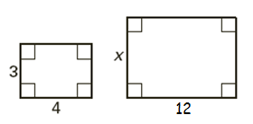
The two polygons are similar. Write a proportion and solve for x.
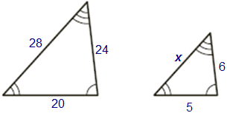
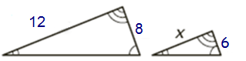
21. 22. 23.

Proportion to find x and solve: Proportion to find x and solve: Proportion to find x and solve:

Find the missing angles and set up proportions to find the missing side lengths.
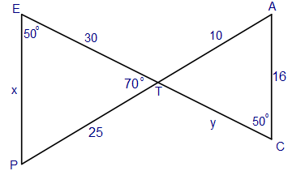
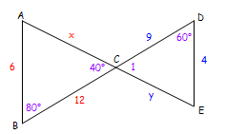
24. 25.

"Flipped" or "Twisted" Bow Tie? "Flipped" or "Twisted" Bow Tie?
$Δ \text{PET}\text{\sim } Δ \text{_______}$ $Δ\text{CAB}\text{\sim } Δ \text{_______}$
Proportion to find x: Proportion to find y: Proportion to find x: Proportion to find y:

m∠P = ______ m∠ATC = ______m∠A = ______ m∠1 = ______ m∠A = ______ m∠E = ______

Determine whether the triangles are similar and explain why (AA~, SAS~, SSS~). If they are similar, write a similarity statement.

26. 27.

Similar? ________ why? _______ ∆ABC ~ ________ Similar? ________ why? _______ ∆FGH ~ ________

28. 29.

Similar? ________ why? _______ ∆LMN ~ ________ Similar? ________ why? _______ ∆EZB~ ________

30. 31.

Similar? ________ why? _______ ∆DEF ~ ________ Similar? ________ why? _______ ∆QMN ~ ________

Complete the proportion using the figure at the right.
32. 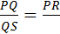 33. 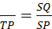

34. 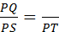 35. 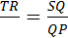

Find the value of x.
36. 37. 38.

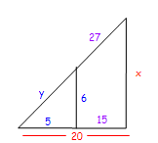
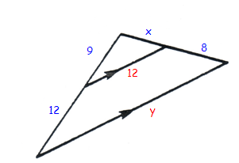
Separate the picture into two labeled triangles and find the missing information.
39. Separate into two labeled triangles. 40. Separate into two labeled triangles

Proportion to find x: Proportion to find y: Proportion to find x: Proportion to find y.

Use the MIDSEGMENT FORMULA to solve for the length of the variable.

41. 42. 43.

Geometry Final Exam Review – Ch. 8 Name:_________________________________
Hour: ____
Decide whether each figure is a concave polygon, a convex polygon, or not a polygon.

1. 2. 3. 4.

Decide whether the polygon is equilateral, equiangular, or neither.
5. 6. 7. 8.

Decide whether the polygon is regular. Explain your answer.
9. 10. 11. 12.

13. What is the formula for the sum of the interior angles of a polygon with n sides? ________________________

For each regular polygon, find the SUM of the interior angles and the measure of EACH interior angle.

14. Octagon (n = 8) 15. Polygon with 15 sides 16. 7-sided polygon

SUM = ___________ SUM = ___________ SUM = ___________

EACH = __________ EACH = __________ EACH = __________

Find the measure of ∠A.
17. 18. 19.

20. What is the sum of the exterior angles of a polygon, no matter how many sides it has? _____________

For each regular polygon, find the SUM of the exterior angles and the measure of EACH exterior angle.

21. Octagon (n = 8) 22. Polygon with 15 sides 23. 7-sided polygon

SUM = ___________ SUM = ___________ SUM = ___________

EACH = __________ EACH = __________ EACH = __________

Find the value of x.

24. 25. 26.

27. How do you find the area of a square?_________________

28. How do you find the area of a rectangle?_________________

29. How do you find the area of a parallelogram?_______________

Find the area of each square, rectangle, or parallelogram.
30. 31. 32. 33.

34. 35. 36.
8 m

Sketch the figure and find its area.

37. a rectangle with a base of 7.2 meters 38. a square with side lengths of 7 yards
and height of 4 meters.

39. a parallelogram with base 24 cm 40. a parallelogram with base 18 in
and height 5 cm and height 25 in

Given the area of the rectangle or parallelogram, find the missing side length.

41. 42. 43.

44. Area = 48 cm² 45. Area = 63 in²

In Exercises 46-48, find the area of the polygon made up of rectangles.

46. 47. 48.

49. How do you find the area of a triangle?_____________________

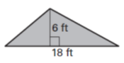
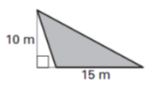
Find the area of the shaded triangle.
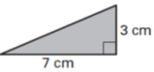
50. 51. 52.

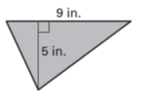
53. 54. 55.
8 ft

A gives the area of the triangle. Find the missing measure.

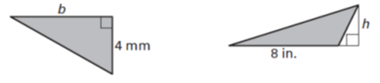
56. A = 14 mm² 57. A = 12 in² 58. If the area of a triangle is 45 yd² and the base is 6 yds,
find the height.

Fill in the following formulas.
59. Area of a trapezoid _____________________ 60. Area of a rhombus __________________________

61. Area of a regular polygon ________________

Find the area of each shape.
62. 63. 64.

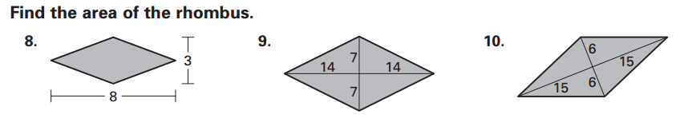
65. 66. 67. A rhombus with diagonals of
length 14 in and 6 in.

68. 69. A regular octagon with sides of length 5mm and
apothem of 9.7 mm.

Find the area of the shaded region.
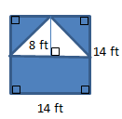
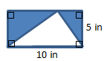
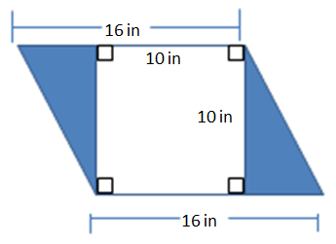
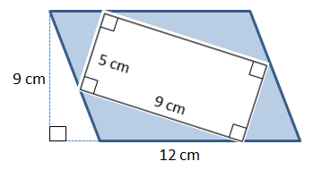
70. 71. 72. 73.

Area of square=______ Area of rectangle=______ Area of parallelogram=______ Area of parallelogram=______

Area of triangle=_______ Area of triangle=_______ Area of rectangle=_______ Area of square=_______

Shaded area=_______ Shaded area=_______ Shaded area=_______ Shaded area=_______

State the FORMULA for CIRCUMFERENCE of a circle: ________________

EXACT: use _________________ APPROX: use ______________________

Find the exact and approximate CIRCUMFERENCE of each circle.
74. 75. 76. Diameter = 20 mm 77. Radius = 4 cm

EXACT circumference __________ EXACT circumference __________ EXACT circumference __________ EXACT circumference __________

APPROX circumference __________ APPROX circumference __________ APPROX circumference __________ APPROX circumference __________

State the FORMULA for AREA of a circle: ________________

EXACT: use _______________________ APPROX: use ________________________

Find the exact and approximate AREA of each circle.
78. 79. 80. Radius = 3 m 81. Diameter = 8 in.

EXACT area __________ EXACT area __________ EXACT area __________ EXACT area __________

APPROX area __________ APPROX area __________ APPROX area __________ APPROX area __________

State the FORMULA for finding the AREA OF A SECTOR: _____________________

Find the area of each sector.

82. 83.

Find the area of the shaded region.

84. 85. 86.
10 cm
4 cm
8 cm

14 cm
Radius of big circle = 6cm
Radius of small circle = 5cm

Exact area of big circle:_________ Exact area of square:_________ Exact area of rectangle:________

Exact area of small circle:_______ Exact area of circle:_______ Exact area of circle:_______

Area of Shaded region: _________ Area of Shaded region: ______ Area of Shaded region: _______

Geometry Final Exam Review – Ch. 9 Name:________________________
Hour: ____

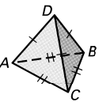
Tell whether the solid is a polyhedron. If so, name the solid.
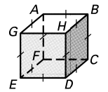
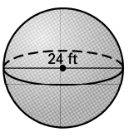
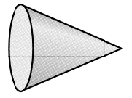
1. 2. 3. 4.

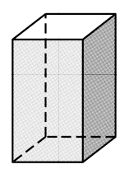
Name the polyhedron. Then count the number of faces and edges.
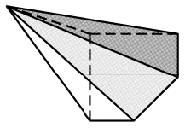
5. 6. 7.

Name: Name: Name:

Faces: Faces: Faces:

Edges: Edges: Edges:

Use Euler’s formula F + V = E + 2 to find the number of faces, edges or vertices.

8. A prism has 6 faces and 10 edges. How many vertices does it have?

9. A pyramid has 6 faces and 8 vertices. How many edges does it have?

10. A pyramid has 12 edges and 7 vertices. How many faces does it have?

Name the solid then find the surface area to the nearest whole number.
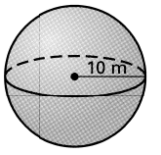
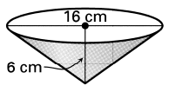
11. 12. 13.

Name: Name: Name:

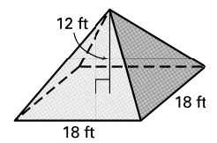
13 cm
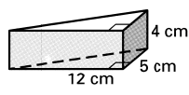
14. 15. 16.

Name: Name: Name:

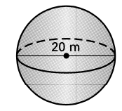
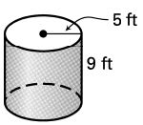
17. 18. 19.

Name: Name: Name:

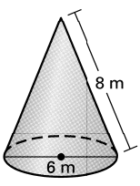
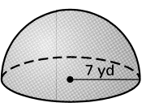

20. 21. 22.

Name: Name: Name:

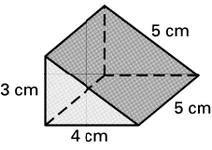
Name the solid. Then find the VOLUME of the solid.
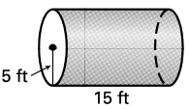
23. 24. 25.

Name: Name: Name:

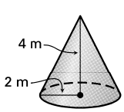

26. 27. 28.

Name: Name: Name:

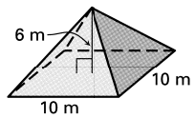
29. 30. 31.

Name: Name: Name:

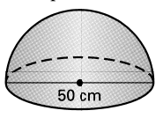
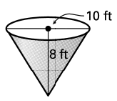
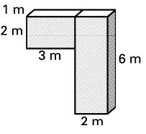
32. 33. 34.

Name: Name:

