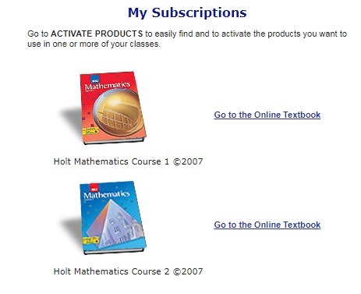
Name _________________________________________________ Hour___________
Course 1 Online Textbook Preview
- Log in with the following information:
Username: parcells1 Password: u8e7v
- Click on “Go to the Online Textbook”.
- Select “Chapter 1: Whole Numbers and Patterns” in the upper left-hand corner on the drop down menu.
- Click on “Lesson 1-3: Exponents” from the drop down menu.
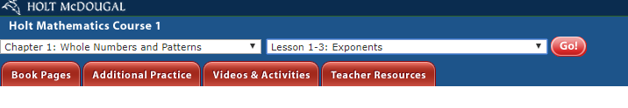
- Click “GO”.
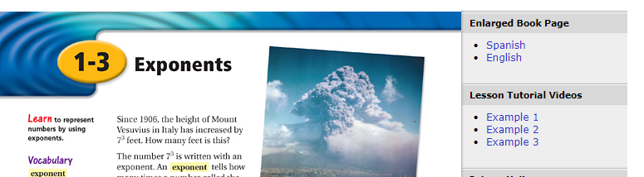
- Watch any one of the videos and WRITE THE EXAMPLES YOU SEE BELOW. If you don’t have headphones, you can put on CC (English) to see the words as Professor Burger speaks.
- Click on Example 1,2 or 3 under “Lesson Tutorial Videos” to watch the video.
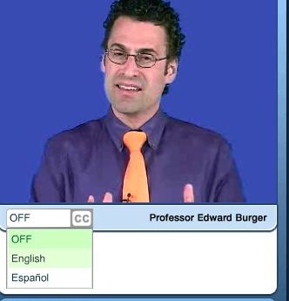
Write examples here:

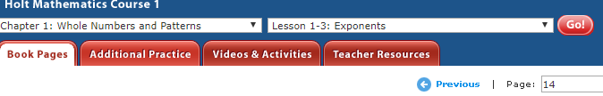
- Click on the “Additional Practice” Tab.

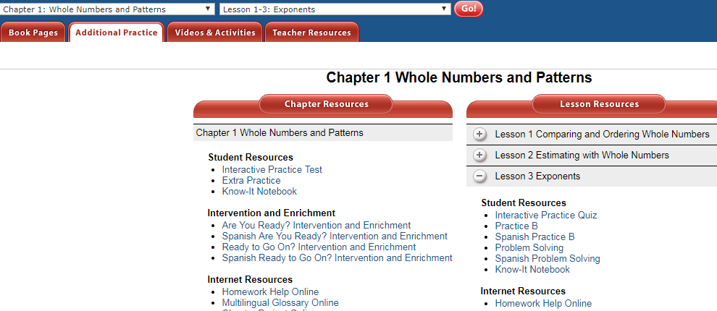
- Click on “Lesson 3”.

- Click on the “Interactive Quiz” and answers all the problems.
Write the quiz problems and answers here:
- ___________2. ____________ 3. ________________ 4. ________________5. _______________

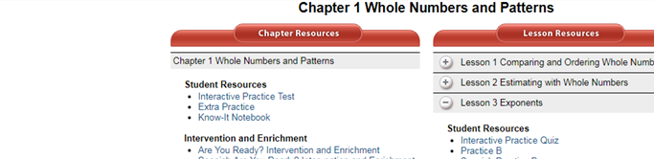
- Click on “Interactive Practice Test”. Answer as many questions as you can.
Record your scores here.

Interactive Practice Quiz score: ______________ Interactive Practice Test score: _____________

- Click on “Extra Practice’. Do the problems below.

Skip the first 16 problems. Start by answering #17 below.

17) _________________________________ 24) _________________________________
18) _________________________________ 25) _________________________________
19) _________________________________ 26) _________________________________
20) _________________________________ 27) _________________________________
21) _________________________________ 28) _________________________________
22) ________________________________ 29) _________________________________
23) _________________________________ 30) _________________________________

Turn over
Take some time to preview other parts of this website. List three other things that you learned that would be useful to you throughout the school year in math.

- ________________________________________________________________________________________________________________________________________________________________________
____________________________________________________________________________________
- ________________________________________________________________________________________________________________________________________________________________________
____________________________________________________________________________________
- ________________________________________________________________________________________________________________________________________________________________________
____________________________________________________________________________________
Name two things you like about the website.
- ________________________________________________________________________________________________________________________________________________________________________
____________________________________________________________________________________
- ________________________________________________________________________________________________________________________________________________________________________

