**Chapter 7 Review** Name___________________________________

*Algebra I CP*

1. Draw a system with 2. Draw a system with 3. Draw a system with

**infinitely many solutions** **one solution** **no solution**

***Solve the system by graphing.***

4. y – x = -4 5. 3y = x + 6

y = x + 3 2x – 6y = -12

Solution:______________ Solution:______________

6. x + y = 2 7.

y = x $-\frac{3}{4}x+y=3$

Solution:_____________ Solution:_____________

***Solve the system by substitution.***

8. x = 5y 9. y – 2x = -7 10. x – 6y = 4

2x + 5y = 15 3x – 4y = 8 3x – 18y = 4

11. 11x – 7y = -14 12. 20x – 30y = -50 13. 2x + y = 9

x – 2y = -4 x + 2y = 1 4x – y = -15

***Solve the system by elimination.***

14. x – 2y = 6 15. 9x – 15y = 24 16. x + 2y = 5

x + 2y = 4 6x – 10y = 16 -3x + 6y = 15

17. 8x – 5y = 11 18. -2x – 5y = 9 19. 4x + 3y = 8

4x – 3y = 5 3x + 11y = 4 x – 2y = 13

20. The sum of two numbers is 20. Their difference is 4. What are the two numbers?

21. You will be making hanging flower baskets. The plants you have picked out are petunias and daisies. The petunias cost $3.00 each and the daisies cost $1.50 each. You bought a total of 24 plants for $48.00. How many of each type of plant did you buy?

22. The perimeter of a rectangular garden is 104 ft. The length of the garden is 8 less than twice the width. What are the dimensions of the garden?

23. Stan bought 3 boxes of Froot Loops and 2 boxes of Kix for $15.05. One box of Froot Loops cost $0.60 more than one box of Kix. How much does one box of each type of cereal cost?

24. A rental company charges a flat fee of *x* dollars for a floor sander rental plus *y* dollars per hour of the rental. One customer rents a floor sander for 4 hours and pays $63. Another customer rents a floor sander for 6 hours and pays $87.

a) Find the flat fee and the cost per hour for the rental.

b) How much would it cost someone to rent a sander for 11 hours?

25. A library is having a book sale to raise money. Hardcover books cost $4 each and paperback books cost $2 each. A person spends $26 for 8 books. How many hardcover books did she buy?

***Tell whether the ordered pair is a solution of the system of inequalities.***

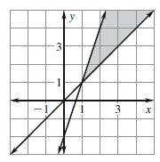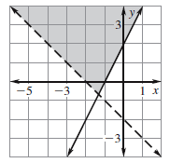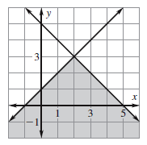26. (1, 2) 27. (-2, 0) 28. (3, 4)

***Graph the system of inequalities.***

29. 30. 31.

32. 33. 34.

***Write a system of inequalities for the shaded region.***

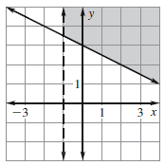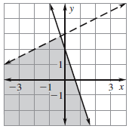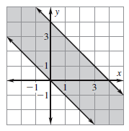35. 36. 37.

**Chapter 7 Review Answers:**

1. 2. 3. 4. No Solution 5. Infinite Solutions 6. (1, 1)

7. (4, 6) 8. (5, 1) 9. (4, 1) 10. No Solution

11. (0, 2) 12. (-1, 1) 13. (-1, 11) 14. (5, -½) 15. Infinite Solutions 16. (0, 5/2)

17. (2, 1) 18. (-17, 5) 19. (5, -4) 20. 12, 8 21. 8 petunias, 16 daisies

22. l = 32 ft., w = 20 ft. 23. Froot Loops: $3.25, Kix: $2.65 24a. Flat fee: $15, Cost/Hr: $12

24b. $147 25. 5 hardcover books 26. yes 27. no 28. yes

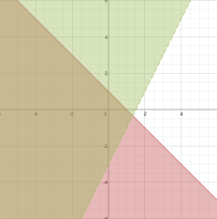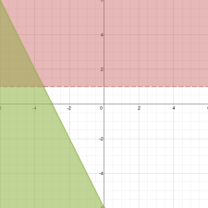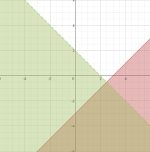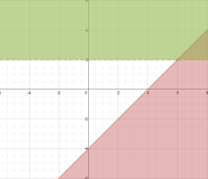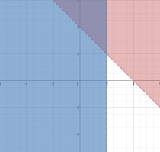29. 30. 31. 32. 33.

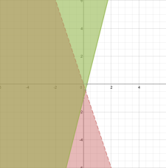

34. 35. 36. 37.